Module 1 – Temperature

Lecture Outline

# Global Temperature Patterns

## Global Energy Balance

* Radiation from the Sun is the primary source of energy to the Earth, with the distribution of energy between the surface and the atmosphere being a main driver for weather processes.
  + 31% is reflected back to space by the surface and atmosphere.
    - This is referred to as albedo, or reflectance.
  + 24% is absorbed by the atmosphere.
    - 3% by the ozone in the stratosphere.
    - 3% by clouds in the troposphere.
    - 18% by atmospheric aerosols (gas and dust) in the troposphere.
  + 45% is absorbed by the surface.
    - 25% by direct solar radiation.
    - 20% by diffuse radiation (sunlight scattered by the atmosphere).
* Due to the rotation and tilt of the Earth, the actual amount of solar radiation reaching any point on the Earth depends on the season and the time of day.
  + The percentages may stay roughly the same, but the total amount of energy will change.
  + The Tropics receive the most sunlight while the Arctic receives the least, leading to a global temperature gradient.
* Since the surface receives more solar energy than the atmosphere, other processes must work to remove the excess surface energy.
  + Conduction, convection, and infrared radiation are the primary surface cooling processes.
  + These processes drive atmospheric motion by changing temperature, pressure, and moisture gradients over space and time.
* These are all averages, and variations in surface and atmospheric properties can lead to substantial variations in these values.
  + Vegetation, topography, soil type, and water bodies play a role in surface energy variability.
  + Cloudiness, greenhouse gas concentration (carbon dioxide, methane, water vapor, etc.), and pollution play a role in atmospheric variability.
* While sunlight generally goes straight through the atmosphere, infrared radiation emitted by the Earth (as part of its cooling process) is easily absorbed and reemitted by gases in the atmosphere.
  + This is called the Greenhouse Effect, and is a critical process for keeping temperatures from dropping too low or too quickly when the sun goes down.

USE AN IMAGE LIKE THE FOLLOWING IN THE POWERPOINT TO HELP ILLUSTRATE THE NUMBERS. YOU CAN FIND OTHERS USING A GOOGLE SEARCH FOR “GLOBAL ENERGY BALANCE”.

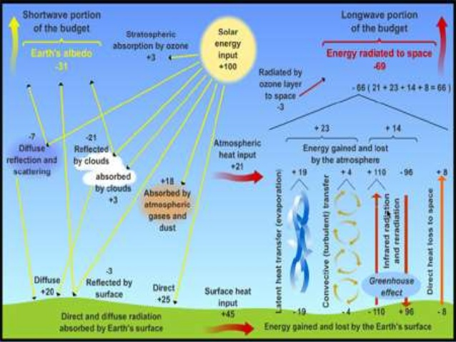

## Energy Balance Over Oceans and Land

* Water can absorb and emit a much larger amount of heat than land due to its high specific heat content.
  + Water = 4,200 J/kg/K
  + Rock = 2,000 J/kg/K
  + Vegetated land = 830 J/kg/K
  + Air = 700 J/kg/K
* Since it takes more energy to change the temperature of water relative to land, oceans and lakes are generally cooler than the adjacent land during the day and warmer at night.
  + These small-scale temperature gradients can lead to changes in atmospheric pressure and wind over an area.
    - Sea breezes along coastal areas, lake breezes near large lakes.
    - This is why coastal areas generally have smaller temperature variations than inland areas.
* Large water bodies can also play a role in seasonal temperature patterns, in that water bodies tend to remain cooler during the summer and warmer during the winter relative to land masses.
  + This process is especially apparent in mid-latitude areas where the amount of solar heating changes substantially over the course of the year.

SHOW A SERIES OF MAPS ILLUSTRATING SURFACE TEMPERATURE DURING DIFFERENT SEASONS. HERE IS A LINK TO A GOOD SOURCE OF IMAGES SHOWING RADIATION AND TEMPERATURE OVER THE GLOBE:

* + - <http://geog.uoregon.edu/envchange/clim_animations/index.html>
* [Provide a brief discussion of areas where seasonal temperatures vary. Look at the Amazon region, the Tibetan Plateau, the Sahara Desert, the western Pacific near Indonesia, etc. for good examples]
  + Include a few slides showing different examples.

## Vertical Temperature Patterns

* Since temperature and heat drive atmospheric processes, the vertical change in temperature with height is used to define atmospheric layers.
* The tropopause is the layer closest to the surface, and it distinguished by a decrease in temperature with height.
  + Since most solar radiation is absorbed by the Earth’s surface, temperature will be highest closest to the surface and decrease from there.
  + Vertical heat (sensible and latent) and radiation fluxes work to transport energy upwards to disperse the excess energy into the atmosphere.
* The stratosphere is characterized by an increase in temperature with height, primarily due to the absorption of solar radiation by the ozone layer.
* The mesosphere and thermosphere are the other two atmospheric layers based on temperature, with temperature decreasing with height through the mesosphere and increasing in the thermosphere.
  + Keep in mind that heat is related to both temperature and density of air, so although temperatures are the highest in the thermosphere it is definitely not warm there!
* As you go up in the atmosphere, there is less of an influence of local-scale surface factors on temperature gradients.
  + Horizontal temperature patterns become more related to the global energy balance, with a general north-south temperature gradient between the Tropics and Arctic.

USE AN IMAGE LIKE THE FOLLOWING IN THE POWERPOINT, OR FIND OTHER BY SEARCHING FOR “VERTICAL TEMPERATURE PROFILE”

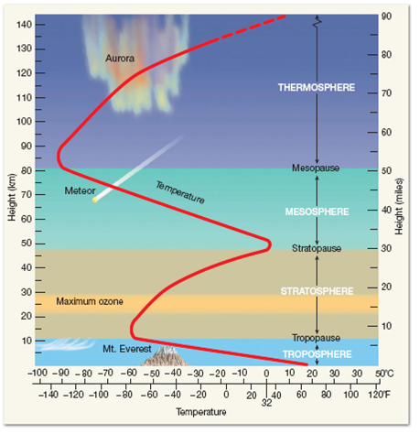

# Daily and Seasonal Temperature Variations

## Understanding Sun Angle

* The amount of solar energy received at the surface of the Earth is dependent on the angle of the sun in the sky.
  + The angle relative to a line pointing straight up is called the *sun angle*.
  + The point on Earth where the sun is directly overhead is called the *subsolar point*.
* Solar angle changes based on time of day, day of the year, and position on the Earth.
  + If you were standing on the Equator (0° N) on March 21 (the spring equinox), the sun would be directly overhead (90° angle) at noon.
  + At a different latitude, day, or time, the sun angle would be less than this.
* As sun angle decreases, the solar energy is spread out over a larger area; therefore, the total amount of energy absorbed at the surface decreases.
  + Less energy means lower temperatures, which mean sun angle and temperature are related.

THERE ARE LOTS OF IMAGES AVAILABLE TO SHOW THE INFLUENCE OF SUN ANGLE AND BEAM SPREADING. JUST GOOGLE “BEAM SPREADING” AND CHOOSE ONES THAT MAKE SENSE TO YOU.

## Seasonal Temperature Cycles

* Seasons on Earth are due to the fact that the Earth is tilted 23.5° on its axis.
  + The subsolar point is at 0° latitude on the spring and autumn Equinox, and at +/-23.5° latitude on the summer and winter solstice, respectively.
* Temperature are highest in the summer in the Northern Hemisphere because that area of Earth is tilted towards the sun. The opposite is true in the winter.
  + Season’s are reversed in the Southern Hemisphere, such that summer begins in December and winter begins in June!
* As seasons change, the mean temperature also changes to reflect the different amounts of solar radiation at the surface.
  + Different types of surfaces absorb radiation at different rates, which is why the hottest part of the year generally occurs after the sun angle is the highest.
  + Oceans tend to have a lower range in seasonal temperatures, while deserts have the greatest range

SHOW TEMPERATURE AND/OR RADIATION MAPS FOR DIFFERENT SEASONS AND DIFFERENT LOCATIONS

HERE’S A GOOD WEB RESOURCE FOR IMAGES AND ADDITIONAL EXPLANATION

<http://expeditieaarde.blogspot.com/2014/02/seasons.html>

## Diurnal Temperature Cycles

* As the Earth rotates, the sun rises in the East and sets in the West. This is called the *diurnal cycle*.
  + The length of a day and the total amount of energy received over the course of a day depends on latitude and season.
* The change in angle of the sun throughout the course of the day causes temperature to vary, with the hottest part of the day usually occurring after the sun has reached its peak angle in the sky (a.k.a., solar noon).
  + Remember that land heats up and cools off faster than water.
* After the sun goes down the Earth emits radiation, which means the coolest part of the day generally occurs just before sunrise.

HERE’S AN IMAGE (OR IMAGES) THAT MIGHT HELP GET THIS POINT ACROSS

<https://atmos.uw.edu/~hakim/101/daily/>

I’M WORRIED THAT I’M TEACHING THIS CONCEPT WAY ABOVE WHAT A MIDDLE SCHOOL STUDENT WOULD UNDERSTANDING, SO PLEASE ADJUST AS YOU SEE FIT.

# 3D Patterns of Temperature

## Global temperature patterns

* Open IDV, then open file “GlobalTempPatterns.xidv”.
  + This will import the 1°x1° GFS file for June 5, 2020 @ 0000 UTC (“gfs_3_20200605_0000_000.grb2).
    - File available from: <https://www.ncdc.noaa.gov/data-access/model-data/model-datasets/global-forcast-system-gfs>
  + The following displays will be loaded:
    - Maps: Blue Marble (underlay), World country outlines.
    - Imagery: Surface temperature (°C).
    - Plan Views: Temperature (°C) at 850, 500, and 300 hPa.
    - 3D cross section showing temperature (°C).
* Features to note:
  + Surface temperatures across the globe are highest in the Tropics (Hadley Cell) and the lowest in the Arctic (Arctic Cell), with the strongest temperature gradients in the mid-latitudes (Ferrell Cell).
    - Visualize surface temperature.
  + Surface temperature varies by topography (elevation), which can be misleading. Meteorologists often adjust temperatures to a constant level to make regional analysis easier.
    - Visualize surface temperature and 1000 hPa temperature.
    - Mean sea level pressure is near 1000 hPa, so temperature at this level is considered “adjusted mean sea level temperature”.
      * Notice the spatial differences between surface temperature and 1000 hPa temperature.
  + As you move up in the atmosphere, the influence of surface heating becomes less apparent. Remember that the surface absorbs most solar radiation and emits thermal radiation, which the atmosphere absorbs; therefore, the surface can be considered the heat source for the atmosphere.
    - Visualize temperature patterns starting at 1000 hPa, then moving up to 850 hPa, 700 hPa, and 500 hPa.
    - The color scales are consistent between the surfaces, so note how the temperature values change as well as the relative temperature gradients.
  + When viewed from pole-to-pole, the vertical and horizontal temperature values show the spatial distribution of energy in the atmosphere (highest in the Tropics, lowest in the Arctic).
    - Visualize the temperature cross section that stretches across the US.
      * Sliding the cross section across the Earth shows the influence of continents and oceans on the latitudinal temperature gradient associated with the climate cells.
    - The individual plan view surfaces can be visualized along with the cross section to help understand both vertical and horizontal patterns.

## Seasonal temperature cycle

* Open IDV, then open file “SeasonalTempCycle.xidv”.
  + This will import 12 1°x1° GFS files corresponding to the 1st day of each month for 2018 @ 0000 UTC (“gfsanl_3_20180101_0000_000.grb2”, etc.).
    - File available from: <https://www.ncei.noaa.gov/data/global-forecast-system/access/historical/analysis/>
  + The following displays will be loaded:
    - Maps: Blue Marble (underlay), World country outlines.
    - Imagery: Surface temperature (°C).
    - Plan Views: Temperature (°C) at 850 and 300 hPa.
    - Isothermal surface (0°C) colored by height (m).
* Features to note:
  + The area of maximum and minimum global temperatures moves throughout the year based on latitude, elevation, surface type (land vs. water), local land cover patterns (i.e., forest, desert, etc.), and weather patterns.
    - Look at how surface temperatures change by latitude through the course of a year.
    - Look at how surface temperatures change over the various continents through the course of a year.
    - Look at how regions of different land cover (i.e., Sahara Desert, South American rain forest, Tibetan Plateau, etc.) change temperature throughout the year relative to adjacent areas.
  + With increasing distance from the surface, seasonal temperature variations become less influenced by regional effects and show more distinct and consistent patterns related to the global climate cells (Hadley, Ferrell, and Arctic).
    - Look at 850 hPa and 300 hPa temperatures and notice the change in the latitudinal pattern of the temperature gradients.
    - Note that the color scales at each level change to better illustrate the temperature gradients.
  + Global temperature gradients are the steepest in the mid-latitudes.
    - Look at the 0°C isothermal (constant temperature) surface, colored by height to help illustrate the steepness of the temperature gradients.
    - Navigate this field in 3D to better realize the structure of global temperature patterns over the course of a year.

## Diurnal temperature cycle

* Open IDV, then open file “DiurnalTempCycle.xidv”.
  + This will import 24 13-km RAP files corresponding to each hour for May 15, 2019 (“rap_130_20190515_0000_000.grb2”, etc.).
    - Files available from: <https://www.ncei.noaa.gov/data/rapid-refresh/access/historical/analysis/201905/20190515/>
  + The following displays will be loaded:
    - Maps: Blue Marble (underlay), World country outlines.
    - Imagery: Surface temperature (°C).
    - Plan Views: Temperature (°C) at 850 and 300 hPa.
    - Isothermal surface (0°C) colored by height (m).
* Features to note:
  + The area of maximum and minimum temperatures across the US moves throughout the day based on elevation, surface type (land vs. water), local land cover patterns (i.e., forest, desert, etc.), and weather patterns.
    - Look at how surface temperatures change over the various climate regions through the course of a day.
    - Look at how regions of different land cover (i.e., desert Southwest, intermountain west, Great Plains, etc.) change temperature throughout the day relative to adjacent areas.
    - Look at the influence of topography on surface temperatures.
  + With increasing distance from the surface, diurnal temperature variations become less influenced by regional effects and show more distinct and consistent patterns related to the global climate cells (Hadley, Ferrell, and Arctic).
    - Look at 850 hPa and 300 hPa temperatures and notice the change in the latitudinal pattern of the temperature gradients.
    - Note that the color scales at each level change to better illustrate the temperature gradients.
  + Regional temperature gradients are the steepest in the mid-latitudes.
    - Look at the 0°C isothermal (constant temperature) surface, colored by height to help illustrate the steepness of the temperature gradients.
    - Navigate this field in 3D to better realize the changing structure of regional temperature patterns throughout the course of a day.

# **Knowledge Test Questions**

* + - 1. Where are temperatures generally the highest and lowest on Earth? Why?
      2. What is the primary source of energy at the Earth’s surface?
      3. What is the primary source of energy to the atmosphere?
      4. What is sun angle, and why is it so important in defining the amount of heat a surface receives?
      5. What causes the seasons?
      6. Why is it colder in the winter than in the summer?
      7. When is the hottest and coldest times of the day? Why?
      8. What is solar “noon”?
      9. Why do horizontal temperature patterns become less distinct as you go up in the atmosphere?
      10. Over what regions are seasonal temperature differences the largest? Why?
      11. Over what regions are diurnal temperature differences the largest? Why?